25/5/2019

|  |
| --- |
| PROJECT BY: |MANOJ|NISHANTH|JASWANTH |

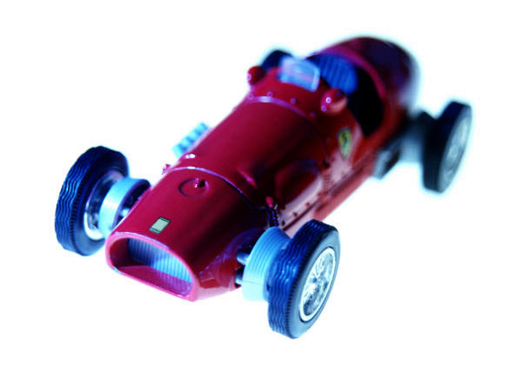

**Objective:** Nowadays the driver safety in the car is one of the most system to avoid accidents. Our objective of the project is to ensure the safety system. For enhancing the safety, we are detecting the eye blinks of the driver and estimating the driver status and control the car accordingly.

|  |  |
| --- | --- |
| SIP PROJECT | DROWSINESS DETECTION |

**Introduction :**

Aimof this project is implementing the system as a prototype by capturing the live images of the eyes and python software is used to process video and convert it into the frames and process it accordingly. Some customized algorithms are coded in python for image segmentation of the eyes from the entire image and image recognition of the eyes and face position.

On the whole, by sensing the eye blinks we can decide if the eye blinks are more then the driver is very sleepy.

**BLOCK DIAGRAM**

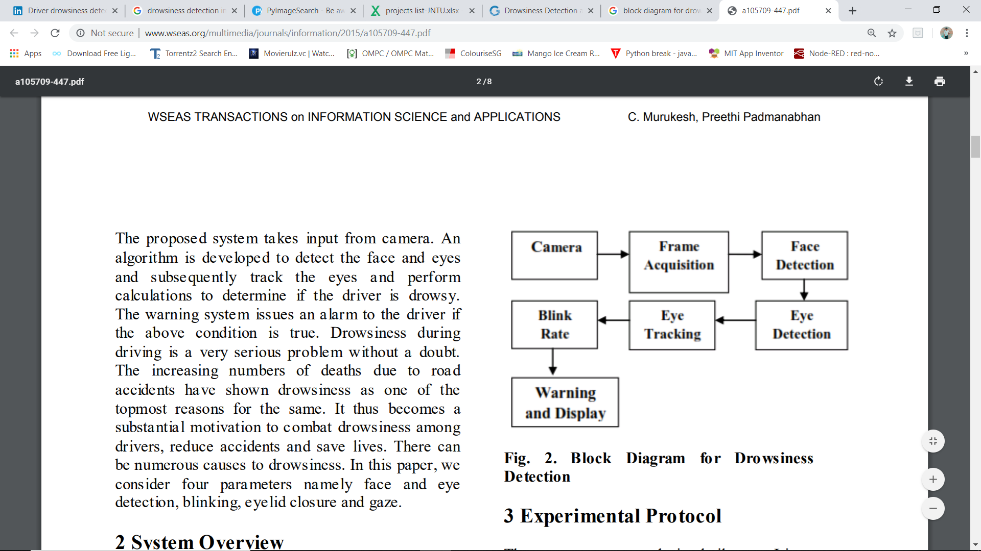

**Output** :

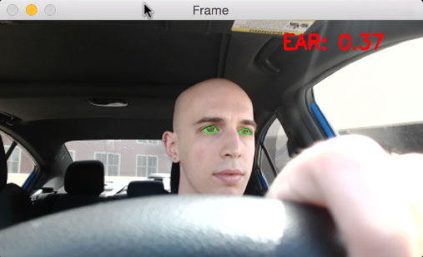

Drowsiness alert:

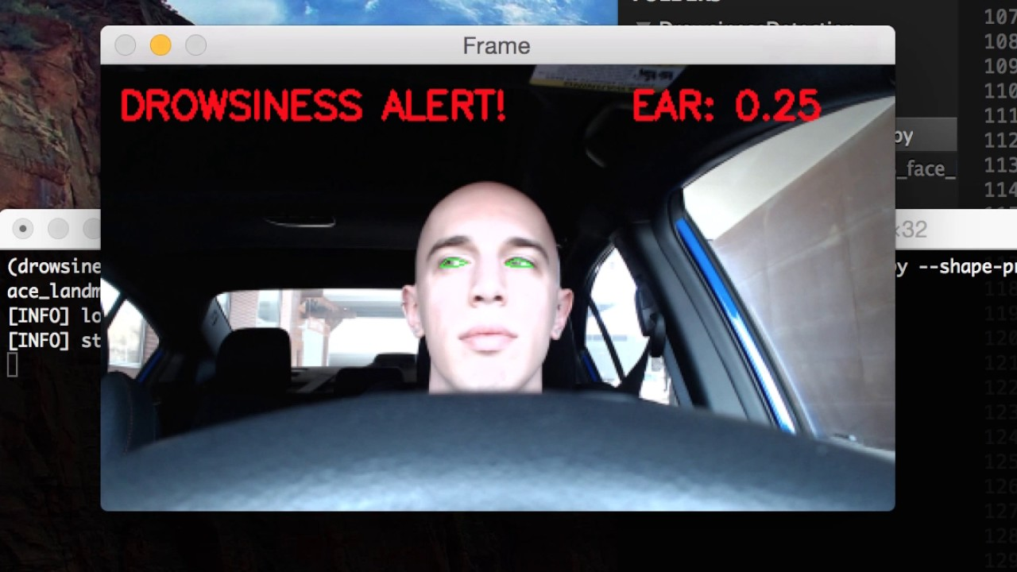

**Python library used are :**

1. Dlib
2. Opencv
3. Imutiles
4. Time

**Sources:**

* **Github.Org**
* **Python.Org**